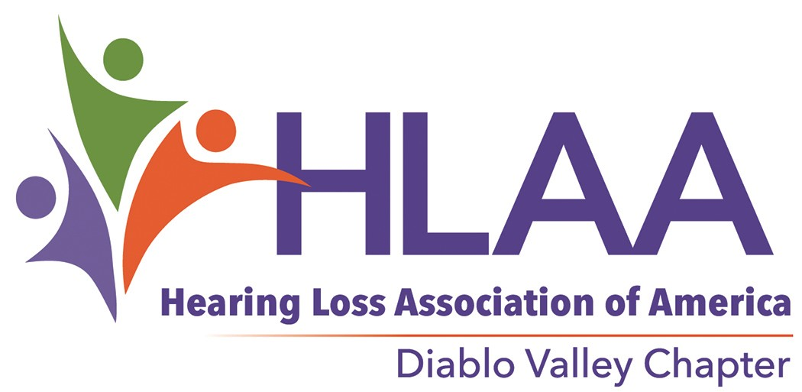

ADA Accommodation Options for Public Venues
The Americans with Disabilities Act (ADA) has the goal of removing barriers to participation in public life and employment for people with disabilities.
While the ADA does not apply to privately owned homes, it does apply to a wide range of facilities and situations. There may be no ADA police, but there are increasing numbers of sophisticated members of the public who are working to further the goals of access and inclusion. An ADA accommodation is as much an act of public relations as it is a potential legal obligation. In addition, states tend to have their own laws about disability accommodations that are as important as the ADA itself.

A general rule of thumb is to ask whether people are able to access the facility and, once in, is effective communication happening?

The ADA doesn't favor any one assistive technology over another. The key to any successful accommodation is to understand what technology is available and who the end users are. This is especially true of the hearing loss community. Although the ADA does not specify any type of ALS, people with hearing aids with a t-coils prefer a hearing loop.

GLOSSARY OF COMMUNICATION TECHNOLOGY
- CART (Computer Assisted Real Time Captioning) - live captioning of speech projected on a screen or portable laptop display.
- Hearing Loop (induction loop) - wireless transmission from sound system to hearing aids or cochlear implant processors equipped with a telecoil. People without telecoils require the use of amplified induction receivers with earphones. Designed for fixed seating venues. Professional installation required.
- IR (Infrared Assistive Listening System) - wireless infrared light transmission from sound system to amplified IR receivers. Designed for fixed seating venues. Professional installation required for large area IR applications.
- FM (Radio Frequency Assistive Listening System) - wireless low power FM frequency transmission from sound system to amplified FM receivers. Designed for fixed seating venues and mobile applications such as tours. Professional installation may be required.
- Sign Language Interpreting - live interpretation between spoken English and Sign Language for the Deaf and Deaf/Blind.
- VRI (Video Remote Interpreting) - live audio/visual sign language interpretation through video conferencing technology.
- The Telecoil is a key piece of equipment that will determine how a person interacts with many communication technologies. This is literally a coil of copper wire inside the hearing aid or cochlear implant processor. It is sensitive to the magnetic fields created by Loop systems and the neckloop accessories for IR and FM listening systems.

PO Box 5495, Walnut Creek, CA 94596-1495 ● 925.264.1199 ● HLAADV@hearinglossdv.org ● www.hearinglossdv.org

THE STRUCTURE OF THE HEARING LOSS COMMUNITY

The hearing loss community is not a homogenous group. People in this population tend to divide themselves roughly into these groups.

- Deaf
- Late deafened
- Hard of hearing
- Deaf & blind

- People with profound or total hearing loss may identify as hard of hearing, Deaf, late - deafened, or as oral deaf. Those communicating in American Sign Language (ASL) tend to identify as Deaf or Deaf/Blind. Deaf with a capital D refers to a person who considers themselves culturally part of the Deaf community. The Deaf communities’ preferred mode of communication is usually ASL. Most people who are late - deafened or hard of hearing do not know or are not fluent in ASL.
- Roughly 70% of people who use hearing aids have Telecoils and all people with cochlear implants (CI) also have a telecoil. People in this technology savvy group prefer accommodations that wireless, easy to use and are discrete. They tend to expect direct access to the ADA accommodation without the need to identify themselves to facility staff. A hearing loop is the preferred accommodation for this group. It allows people from this group to walk in, take their seat, discretely activate the telecoil in their hearing aid or cochlear implant, and receive an amplified signal from the facility's sound system without having to spend extra time before and after an event signing out and returning amplified receivers and earphones. Additionally, headset do not usually work well with hearing aids. FM and IR listening systems can be optimized for this group with the use of neckloops in place of headsets. The neckloop plugs into the headset jack on the amplified receiver and is worn like a necklace. It communicates the amplified audio signal wirelessly to the telecoil in the hearing aid or CI processor. Neckloops are a required component of an FM or IR assistive listening system.
- Finally, there are a large number of people within the full range of hearing loss who do not use hearing aids or their hearing aids do not have a telecoil. People in this group are likely to take advantage of any opportunity to hear better and will need to use amplified receivers with headsets in order to access the FM, IR, or hearing loop system.

Hearing loss is a very personal experience. Naturally, not every individual is going to fit into this rough classification. No single ADA technology will serve the entire hearing loss population, but a well considered ADA plan can address permanent and occasional accommodation requests in a way that does not exceed the expectations of reasonable effort required by the ADA.

ADA Hearing Loss Accommodation Technologies for Public Venues

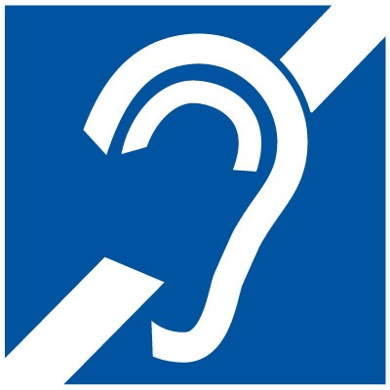
International Symbol of Access for Hearing Loss 703.7.2.4

 | Deaf | Deaf Blind | Oral deaf, Profound Hearing Loss | Hard of Hearing | Hard of Hearing with Telecoil | Cochlear Implant with Telecoil
Sign Language Interpretation | X | X
Oral Interpretation |  |  | X | X | X | X
VRI | X
CART | X |  | X | X | X | X
Loop System |  |  | X | X | X | X
FM System |  |  | X | X | X | X
IR System |  |  | X | X | X | X

VRI—Video Remote Interpreting

CART—Communication Access Real Time Translation, captions Loop system—Induction Loop Assistive Listening System FM—FM Assistive Listening System
IR System—Infrared Assistive Listening System

MAINTENANCE REQUIREMENTS FOR ADA LISTENING SYSTEMS

Every accommodation is unique.

- Once professionally installed, Loop systems need to be protected during any renovations in the future that may break the loop wire. Also, tests should be run when adding electrical equipment (new lighting, audio/video equipment, computer technology, etc.) in the looped area to make sure there is no electromagnetic interference generated by the new equipment.
- Large area IR transmitters, with their custom lengths of audio cables, must be permanently mounted on the walls. These may need to be reoriented or remounted with new lengths of audio cables if there is a change to the position of the seating area.
- Although the law protects the band of frequencies used by FM transmitters and receivers, occasionally high-powered radio sources can cause accidental interference and static. Staff would need to change the built-in frequency controls on the transmitter and receivers to avoid such interference if it should occur.
- ADA listening systems using amplified receivers (IR, FM, and Loops) require staff members to sign out and later collect amplified receivers and earphones in order to prevent accidental loss. The foam pads on receiver earphones and headsets should be washed with soap and water on a routine basis or there are disposable sanitary covers available for headsets. Silicon ear tips should be cleaned with soap and water or non-alcohol cleaning wipes after each use. Weak batteries can affect the quality of sound in the receivers. Regular battery checks should also be a part of routine maintenance.
- Any audio problems in the existing sound system will be reproduced in the ADA listening equipment. Maintenance of wireless microphones and other audio equipment is key to long-term success of an ADA system.

Reprinted with permission: Hearing Speech and Deafness Center: http://hsdc.org

4 10.17.17

