

[HLAADV@hearinglossdv.org](mailto:HLAADV@hearinglossdv.org) [www.hearinglossdv.org](http://www.hearinglossdv.org/) 925.264.1199



**for**



**Are you having difficulty understanding speech?**



communication access

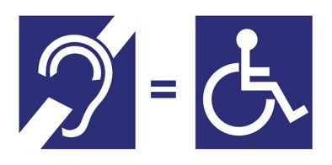

**Communication access** helps people with hearing loss the same way ramps help people with mobility issues.

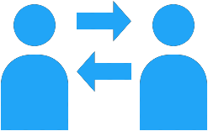

**Accessibility**



ASK

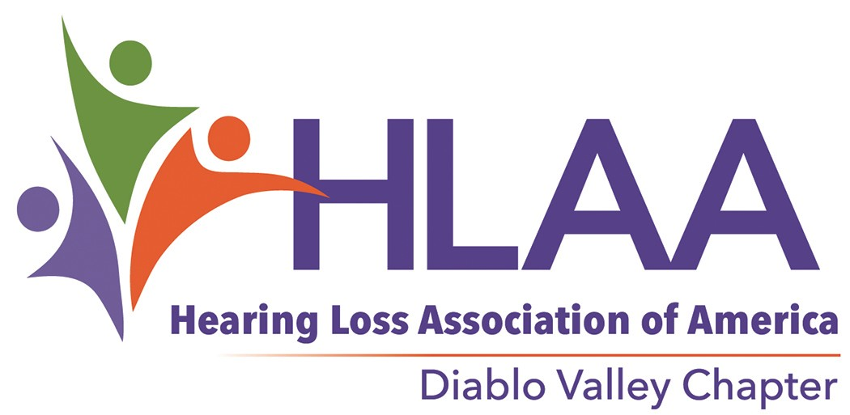

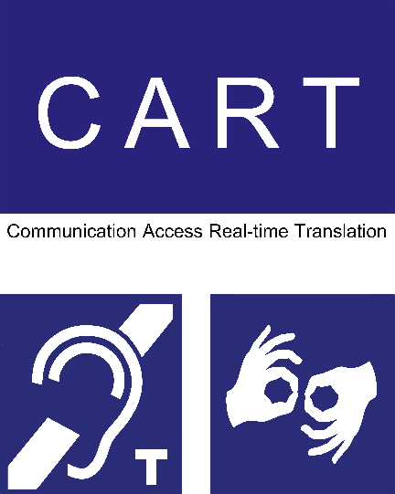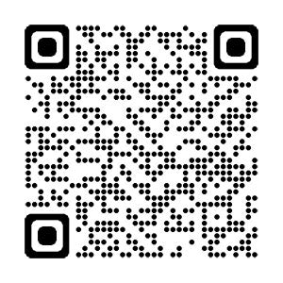

**Diablo Valley Chapter**

**Monthly Meetings**

1st Saturday of the month

MEETINGS ARE VIRTUAL UNTIL FURTHER NOTICE

Check website for additional information

[www.hearinglossdv.org](http://www.hearinglossdv.org/)

We provide

communication access

Our meetings are captioned. The meeting room has a hearing loop. ASL on request.

06/18/22



**Providing Effective Communication**

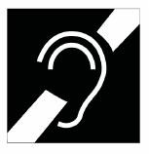

**Communication Access**

Symbol of Access for Hearing Loss



**It’s the Law!**

Hearing loss Is a disability covered under the American with Disabilities Act (ADA) and California civil rights laws.

**What areas of public life are required to comply**?

* Employment
* Education
* State and local government
* Public accommodations
* Telecommunications

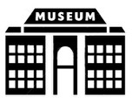

**Where? Everywhere!**



# How to Ask for the Help You Need?

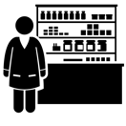

**Assistive Listening Systems**

Hearing loop FM

Infrared

FM & Infrared + neckloop = HAC

**Captions**

Real Time Remote Closed Open

**Translation**

ASL

Finger signing Aural

Hearing Aid Compatibility (HAC)

Use a computer search engine, like Google, to find the event you would like to participate in. On the events home page look for an accessibility contact person by searching, using the words ADA, ADA coordinator, accessibility or disability.

Contact that person and ask for communication assistance to use their services or participate in a program or event.

hard of hearing • late-deafened • Deaf • deaf-blind