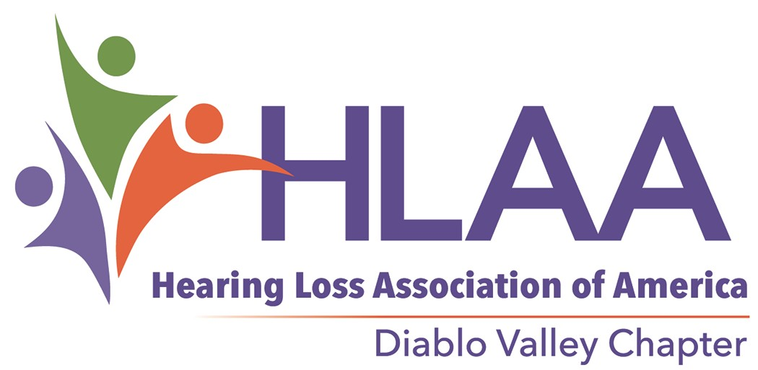

Monthly Meetings
Do You Have a Disaster Preparedness Plan?

ATTENTION

Create A
Plan Today!
See website for time and location.

www.hearinglossdv.org

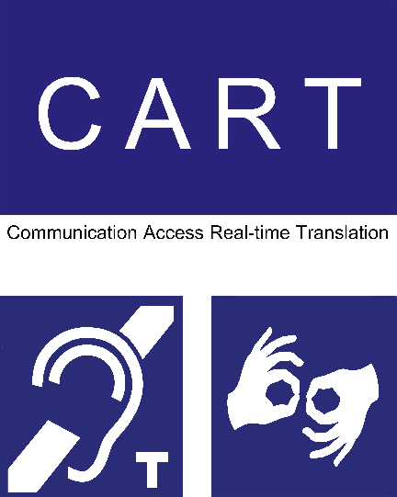

We provide communication access
Our meetings are captioned. The meeting room has a hearing loop. ASL on request.
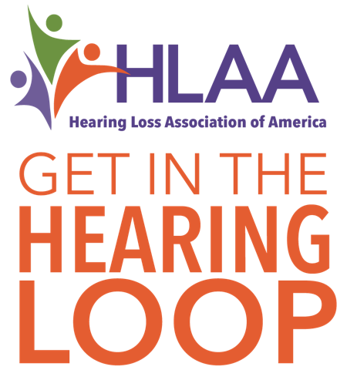
GITHLinfo@hearinglossdv.org
Disaster Planning

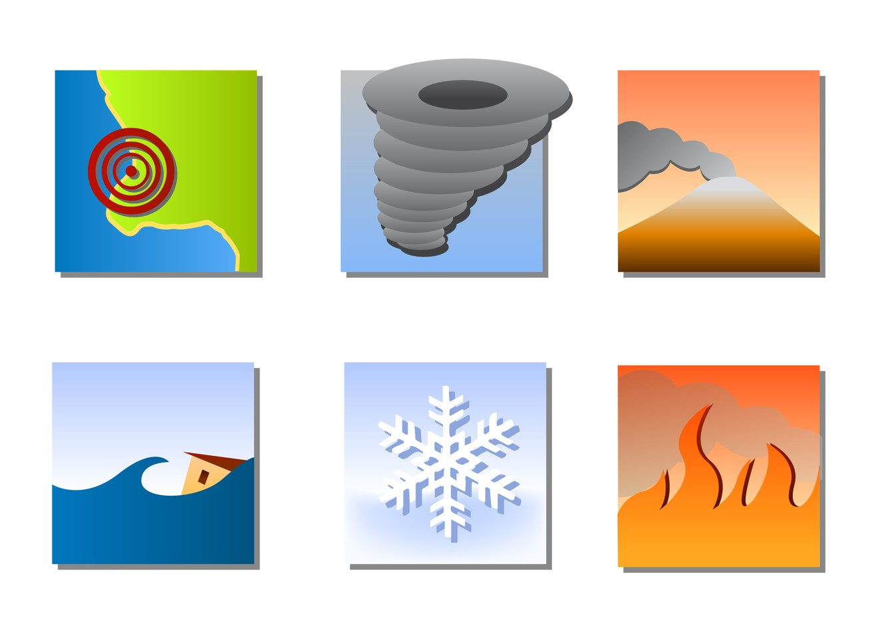

Hearing Loss Association of America
Diablo Valley Chapter 925.264.1199
www.hearinglossdv.org

9.5.18

Get Organized Today!

People with a hearing loss can be at a great disadvantage in a disaster if they don’t plan appropriately.

Missing or damaged hearing aids will cause many problems for you following a disaster.

If you are traveling, ask the hotel if they have an alertin1g0.1d4e.1v7ice or bring your own.

- What do you currently have in place?
- Purchase missing items from the checklist.
- Store all of your items in an easy to access location.
- Inform your network where they are kept.
 Batteries
Store and maintain extra batteries.
- Zinc air
- Rechargeable batteries
- Solar battery charger

 Hearing Aids
Store in a convenient location and attach them to a fixed object like a nightstand, so they are easy to find.

 Alerting Devices Install audible; visual; and vibration smoke and carbon monoxide alarms.

 Support Network
- Make an emergency contact list. Include at least one person out of state.
- Local Emergency Teams: CERT
- Fire Department
- Register Reverse911
- Register for SMART911

 Warning Systems
- NOAA Weather Radio/All Hazard Alert Radio
  - With text message
  - Strobe light with auditory
signal
  - Bed shaker
- Local Emergency Alert System (EAS), TV stations are mandated to display emergency broadcasts with captions.

 Communication
- Write down key phrases for emergency personnel.
- Paper and pen.
- Flashlight, camping lantern to assist with speech/lip reading.
- Face Me Button.
- Keep your cell phone charged and have a car charger. Put an emergency contact in your phone contacts under In Case of Emergency (ICE).

TIP
Some bed shakers can be clipped right to the pillowcase so they do not get misplaced.

