Are You Hearing Everything You Could?

Hearing Loss Association of America
7910 Woodmont Avenue, Suite 1200 • Bethesda, MD 20814 • 301.657.2248 • Fax 301.913.9413 • hearingloss.org

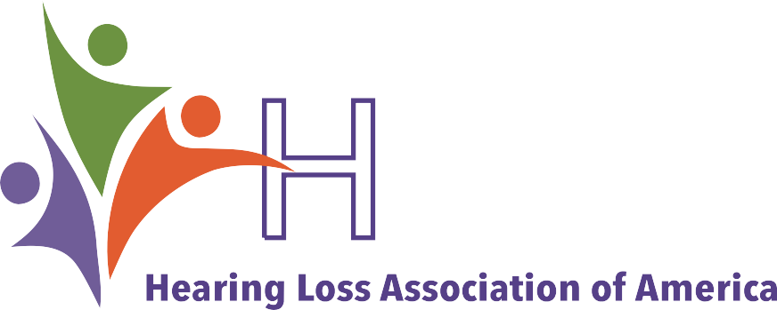Hearing Assistive Technology and a Telecoil Might Be the Key to Better Hearing

Hearing assistive technology (HAT) can dramatically improve the lives of people with hearing loss. HAT, also referred to as an assistive listening system (ALS) or assistive listening device (ALD), bridges the gap between you and the sound source by eliminating the effects of distance, background noise, and reverberation. They can bypass challenging acoustics by sending sound directly to the person’s ears.

Hear Better in Public Places
HAT bridges the gap between you and the sound source by eliminating the effects of distance, background noise and reverberation. An ALS is the gateway through which people with hearing loss access sound from a public address system. But in order to easily connect to a sound source or ALS it is imperative that your hearing aid, cochlear implant or streamer be equipped with a telecoil.

Ask Your Hearing Care Provider About Telecoils
Telecoils expand the usefulness of hearing aids and cochlear implants, especially in environments where it is typically challenging to hear clearly. A telecoil (or t-coil), is a small copper wire that is available on most
hearing aids, all cochlear implant processors, and some audio streamers. T-coils are an essential component for
anyone wishing to easily and directly access an assistive

Most hearing aid models—more than 70 percent— either come with a telecoil or offer it as an option
(all cochlear implant processors made today have a telecoil). However, make sure to ask your hearing care provider to confirm that the hearing device you are purchasing has a telecoil and that it is programmed and activated.

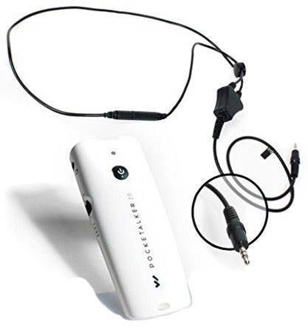No Hearing Aid or Telecoil? No Problem!
People who do not wear hearing aids or whose hearing aids do not have a telecoil can still use assistive listening systems with
a receiver and headphones. You can also use a telecoil-equipped
personal amplifier or special telecoil- equipped earbuds and a smartphone.
In addition, the Americans with

listening system or use an ALD. (Note: an assistive listening system is usually for many people whereas an assistive listening device is one-to-one.)
Hearing devices with a telecoil can have a dramatic impact on your ability to hear clearly on the telephone, in meetings, when attending a lecture, in a place of worship, at the theater, in a noisy restaurant, while navigating airports, bus and train stations, and in other challenging environments. When telecoils are used together with
any type of hearing assistive technology it can make a noticeable difference in your life. It allows sound to be transmitted directly from the source to your hearing device, eliminating most of the background noise.
Disabilities Act (ADA) requires that state and local governments, along with businesses and nonprofit organizations that serve the public, provide equally effective communication access for people with communication disabilities as those without a disability. All assistive listening sytems are required to be accessible by people with hearing aids, with hearing aids but
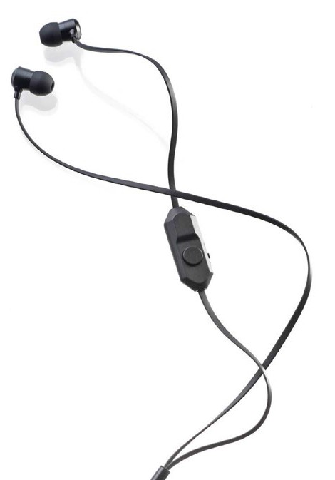no telecoil, and without hearing aids. Hearing loops, FM and IR systems all meet this mandate.
Williams Sound, LLC’s
Pocketalker (above) and OTOjOY’s LoopBuds (below) are examples of assistive listening devices that can help reduce background noise in louder environments.

If you struggle to hear but don’t yet have a hearing aid or cochlear implant, an assistive listening system can still help.

Assistive Listening Systems
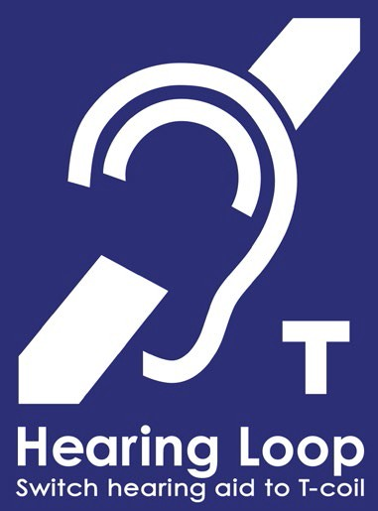Hearing loops, or induction loops, consist of a copper
wire placed around a room which is connected to a public address or sound system. An electromagnetic field is created that connects to a telecoil in hearing aids, cochlear implants or a telecoil-enabled device such as a streamer or LoopBuds.
Loops are the most user-

What Is an Assistive Listening Device?
An assistive listening device (ALD) expands the functionality of hearing aids and cochlear implants by helping separate the sounds you want to hear from background noise, and by enabling you to hear when the speaker is more than a few feet away.
A wireless ALD consists of a transmitter, receiver and microphone. A person can connect to the receiver via a neckloop, headphone or earbuds.
The speaker uses the microphone to transmit sound to the person, thus reducing the degrading effects of noise and distance on speech intelligibility. An example of how you might use an ALD is communicating with

friendly of the assistive listening
options and the first choice for many users. Hearing loops are simple, discreet and effective. By simply switching the device to the telecoil program the user receives sound directly.
This universal symbol lets you know there is a hearing loop installed in the room
or venue.
your child at a large family gathering. The child speaks into the microphone and the sound is transmitted to your hearing device reducing competing noise so you can understand them more clearly.

Using Bluetooth with Your Hearing Device

People who do not have hearing aids or who do not have access to telecoils in their hearing aids or streamer need to use a hearing loop receiver and headphones to connect to the system.

Infrared (IR) systems work like a TV remote control. A transmitter sends speech or music from a public address or sound system to an IR receiver using invisible infrared light waves. This technology is line of sight and cannot be used outdoors during the daytime as daylight will interfere with the signal. Because IR signals are sent and received in a straight line, users are encouraged to sit as centrally as possible; those sitting in balconies or other areas with a poor line of sight might experience interference or receive no sound signal at all.
Anyone who uses an IR system needs a receiver and either headphones or a neckloop. For those who have telecoils in their hearing aids and cochlear implants, neckloops eliminate the need for headphones.

FM or RF (radio frequency) assistive listening systems use a low-power FM frequency radio signal to wirelessly transmit sound from the source to a receiver. An advantage of this system over an infrared system is that it is not affected by direct sunlight. FM systems are frequently used by students with hearing loss in the classroom.
Everyone using the FM system needs a receiver and either a neckloop or headphones. For those who have telecoil-equipped hearing aids and cochlear implants, neckloops eliminate the need for headphones.
Bluetooth is a relatively short-range wireless technology frequently used to connect cellphones, televisions, computers, tablets and, more recently, hearing aids
and cochlear implants. Bluetooth technology in hearing devices is proprietary, that is, designed for a specific brand and/or model of the device. While this technology is evolving, it is still generally not suited for long-range transmission in a large venue such as an auditorium or theater.

What Can I Do to Hear Better in Noise?
People with hearing loss typically find it challenging to hear in environments with background noise. One of the simplest ways to help hear better in these situations is to use a personal amplifier. A personal amplifier is a single unit with jacks for a microphone and a listening attachment and which also includes volume control.
These devices help reduce the effects of background noise when you are close to the speaker, such as in a car or restaurant.
There are also ways to hear better in noise when the speaker is more than a few feet away. FM, IR, and hearing loop systems transmit sound over longer distances, such as a student hearing a teacher who is speaking from the front of the classroom. All of these
systems can be scaled for use in both smaller and larger environments (e.g., homes and auditoriums).

Tips

When purchasing a hearing aid don’t assume it will automatically come with a telecoil or even if one will be recommended by your provider. Also, if a telecoil is present don’t assume it has been programmed to suit your individual needs.
- More than 70 percent of all hearing aids dispensed in the United States today have telecoils, yet few consumers are told about them and know how to use them. You can use the HLAA Consumer Checklist when purchasing
a hearing aid (available for download at hearingloss.org or ordered in hard copy from the HLAA Online Store) to assist you in making a purchase decision. In addition to other helpful information, the checklist includes asking about telecoils. Some states have laws that require

audiologists and hearing instrument specialists to tell consumers about telecoils when purchasing hearing aids.

About the Hearing Loss Association of America
The Hearing Loss Association of America (HLAA) is the nation’s leading organization representing the 48 million Americans with hearing loss.
HLAA publishes the bimonthly magazine, Hearing Life, holds annual conventions, produces the Walk4Hearing, offers training courses and online learning, holds monthly webinars and advocates for the rights of people with hearing loss. The national support network includes the Washington, D.C. area office, state organizations, and more than 150 local chapters across the country.
- Be sure to check with your audiologist or hearing instrument specialist to ensure that the settings for your telecoil are maximized for use with assistive listening devices.

- Access to public places for individuals with disabilities is required by the Americans with Disabilities Act (ADA) and state laws. If you think an assistive listening device would benefit you on the job or in your classroom, you should find out the process
from that facility for requesting a reasonable accommodation (in private settings) or for auxiliary aids and services (in public settings).
- Advocate for the installation of assistive listening devices and systems in venues within your community, such as city council chambers, community centers, classrooms and places of worship. Encourage the venue to advertise that they have these available so others can take advantage of them as well.

Hearing Loss Association of America
7910 Woodmont Avenue, Suite 1200 • Bethesda, MD 20814 • 301.657.2248 • Fax 301.913.9413 • hearingloss.org
facebook.com/HearingLossAssociation
@HLAA
@hearinglossassociation
9.2018

Get more information and support from your local HLAA Chapter!
Chapters are a place to meet others who are just like you right in your own community. For more information and to find an HLAA Chapter near you go to hearingloss.org.

Mention of goods or services does not constitute Hearing Loss Association of America endorsement, nor should exclusion suggest disapproval.

