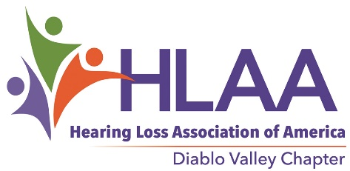

Do You Know About the Hearing Loops in Rossmoor?
Look for this symbol in the room

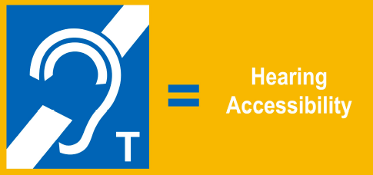
Hearing Loop
Switch hearing aid to T-coil
Assistive Listening Systems provide people with hearing loss what
wheelchair ramps offer for people with mobility issues. ACCESS
Assistive Listening Systems in Rossmoor Rooms
Location |  | Room |  | Type
Creekside Complex |  | Club Room |  | Hearing Loop
1010 Stanley Dollar Drive |  | Fairway Room A |  | Hearing Loop
 |  | Fairway Room B |  | Hearing Loop
Dollar |  | Solarium |  | Hearing Loop
Event Center |  | Tahoe Room |  | Hearing Loop
1021 Stanley Dollar Drive |  | Donner Room A |  | Hearing Loop
 |  | Donner Room B |  | Hearing Loop
Gateway Complex |  | Art Studio 1 |  | Hearing Loop
1001 Golden Rain Road |  | Fireside Room |  | Hearing Loop
 |  | Multi-Purpose Room 1 |  | Hearing Loop
 |  | Multi-Purpose Room 2 |  | Hearing Loop
 |  | Peacock Hall Theater |  | Hearing Loop
Hillside Clubhouse |  | Vista Room |  | Hearing Loop
3400 Golden Rain Road |  | Las Trampas Room |  | Hearing Loop
 |  | Diablo Room |  | Hearing Loop
Contact
 | Avi Singh |  | ASingh@Rossmoor.com
 | Audio Visual |  | 925-988-7816

