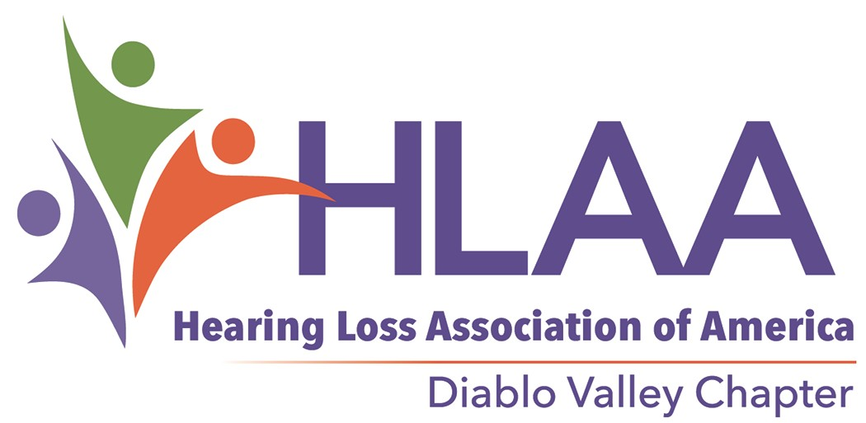Do You Have an Alerting Device You Could Hear?

Smoke and carbon monoxide detectors sound at a frequency that may not wake or alert people who are hard of hearing or Deaf
Monthly Meetings
See website for time and location.

info@hearinglossdv.org

We provide communication access
Our meetings are captioned. The meeting room has a hearing loop. ASL on request.

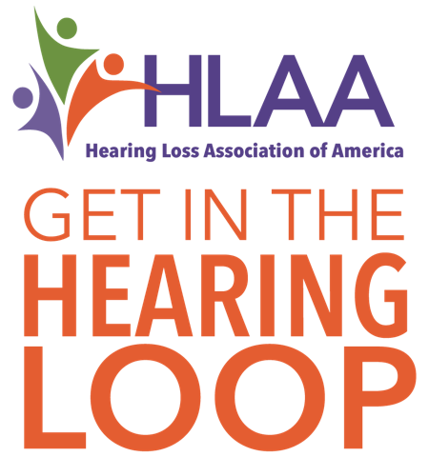

9.518ART

ATTENTION
Safety

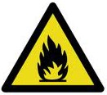

Fire

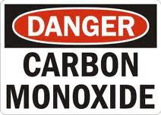

Hearing Loss Association of America
Diablo Valley Chapter
925.264.1199

www.hearinglossdv.org

Make your home, fire and carbon monoxide safe today!

Safety!
- Get out fast—research shows that once a smoke detector is activated from a fire in your home, you may have as little as two minutes to escape unharmed.

- A carbon monoxide alarm is a signal of a potentially deadly hazard.

- People who are hard of hearing or deaf may not be alerted to a fire or exposure to carbon monoxide by a normal smoke or carbon monoxide detector.

- Recent research shows that most people with a hearing loss, even a mild one, will not be awakened from a deep sleep by a standard smoke detector.

- Hearing loss typically affects the high tones more than the low tones. A standard smoke detector emits a 3100 Hz high tone signal.

- A standard smoke detector, for a person who has a hearing loss, increases their risk of not getting out of their home safely during a fire.

Alerting

Sound ● Vibrate ● Strobe

  - Get a system that sends multiple alerting signals around your home.
  - Use more than one type of alert to be fire and carbon monoxide safe:

low tone bed shaker flashing

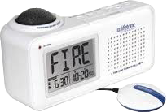
Lifetone

A low tone alerting device and a bed shaker are the most effective ways to be awakened from a deep sleep.

The information in this document is meant to be used for educational and guidance purposes only.

- 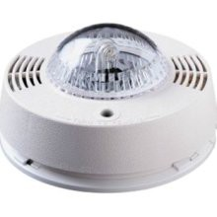A visual strobe light may be effective during the day however strobe lights are the least effective devices during sleep.

TIPS
- Make sure you wear your hearing aids during the day to help you hear the smoke or carbon monoxide detector.

- Interconnected smoke alarms are recommended so your alerting device is activated no matter where the fire takes place in your home.

- Some bed shakers can be clipped right to the pillowcase so they do not get misplaced.

- Make sure your alerting device is compatible with your smoke alarm!

- If you are traveling, ask the hotel if they have an alerting device or bring your own.

